Creating Landscape Diversity

A Homeowner’s Guide

What is the urban watershed?

North Carolina’s watersheds consist of several large drainage basins whose surface waters all flow into area rivers. We generally consider the forests, fields, farms, and wetlands when describing these watersheds, but rarely do we think to include the urban and metropolitan areas falling within their boundaries.
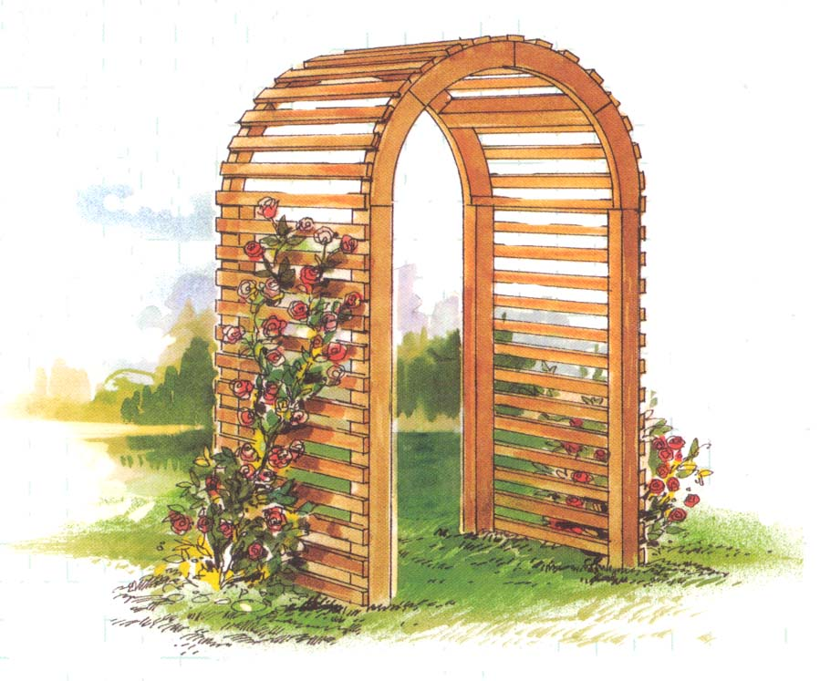

As in the larger river watersheds, urban watersheds drain surround-ing land surfaces. While metro-politan communities play an integral role in the health of our rivers, we don't always make that connection as we go about our daily lives. Hundreds, even thousands, of local creeks and streams that feed into local rivers or tributaries are piped under ground, channeled above ground in concrete, directed into storm-water detention ponds, moved under cities through large culverts, or fed into deep under-ground sewers. Others remain open and drain through community parks, large residential complexes, and urban subdivisions. Local stream corridors provide essential wildlife habitat as well as much needed recreational and open space for people. Together, this network of natural and engineered waterways, along with the land drained by it, defines the urban watershed.

Land practices and landscape cover within the urban watershed play an important role in the health our eco-systems. In North Carolina, landscapes that provide plant and wildlife diversity and pollution prevention are called Conservation Landscapes.

Landscaping and Gardening Without a Yard

City residents may be faced with a variety of landscape choices. If you are an apartment dweller, you might think of your landscape or garden as small or insignificant but, in fact, it provides tremendous relief from the artificial environment. The simple addition of a potted vine making its way up a wall, adding color and texture to the surface, can be dramatic. It does not require a lot of effort or expense to greatly improve a small-scale garden area and, in doing so, you are making your city more livable by adding to the visual aesthetics shared by all.
Small-scale urban landscaping may also be quite portable. Almost any species of plant will grow in a container and, as such, move when you move. And if your garden is containerized, you can substantially change its appearance with little effort or money. Container plants can be shuffled around, lowered or raised, or re-potted for a distinct, new look. Use native plants whenever possible.
This guide is adapted from an environmental education initiative developed by the Alliance for the Chesapeake Bay and the U.S. Fish and Wildlife Service, Chesapeake Bay Field Office. Modifications provided by N.C. Partners in Flight and the Stevens Nature Center, Town of Cary, N.C.

One unexpected benefit for urban gardeners is the heat island phenomenon, which actually extends the gardening season. In the spring, urban areas tend to warm up faster, while in the autumn, they hold their summer heat a bit longer. Such local site conditions are often referred to as microclimates, and the clever gardener can get a jump on the growing season and enjoy the outside landscape just a bit longer before winter arrives.

How can I provide water for wildlife?

By practicing water conservation techniques you will be able to allocate water for the wildlife. Water is critical to North Carolina inhabitants, since naturally occurring sources are declining or seasonally stressed. Direct watering can be as simple as putting out a birdbath or a shallow pan of water to provide a drink for thirsty birds, butterflies, and other wildlife passing through your yard. For frogs, turtles, salamanders, and other aquatic species, you may want to provide a small garden pool, complete with nearby plantings of fruit-bearing native trees and shrubs. Provide water for shy animals near a brush pile or other safe cover. No matter how you provide wildlife with water, you will be pleasantly rewarded. Keep water sources clean as needed.

Isn’t landscaping and gardening expensive?

No matter where you live, you can participate in many aspects of landscape gardening with a surprisingly modest budget. Balconies support a host of gardening options, from containerized trees and shrubs, to vines and bulbs in pots, to vegetable plants and herbs in tubs. Small water gardens and wall gardens also thrive in small spaces. As long as you provide adequate sunlight and regular watering, you can create a wonderful little garden for yourself as well as a

haven for wildlife. Think of your garden as a wildlife oasis that you created, providing another link in the restoration of lost or seriously fragmented wildlife habitat in North Carolina.

HARDY GROUND COVERS
Common/  Scientific Name | Height | Description  (all shade loving species) | Reproduction/  Habitat Preferences
Wild Stone Crop  Sedum ternatum | 3’’ | Blue-green, disc shaped leaves; white, starry flower clusters | Propagate by division, cuttings or seeds; prefers thin alkaline soil
Creeping Phlox  Phlox stolonifera | 3-10’’ | Triangle-shaped and small oval leaves; 5-lobed flowers in blue, pink. white | Spreads by underground runners; prefers moist, well-drained, acidic soil
Crested Iris  Iris cristata | 6’’ | Green dagger-shaped leaves; lavender/purple/ blue flowers | Propagate by division; prefers moist, well-drained, acidic soil
Green-and-Gold Chrysogonum  virginianum | 6-15’’ | Deep green, oval leaves; profuse yellow star-like blooms | Spreads by underground runners, division and prostrate stems; prefers neutral, well-drained soils
Wild Ginger  Asarum canadense | 8’’ | Cupped, heart-shaped leaves; brown, 3-petaled trumpet blooms | Spreads by underground stems and division; prefers moist, well-drained, fertile soils
Foam Flower  Tiarella cordifolia | 6-12’’ | Evergreen, heart-shaped leaves, small whitish to pink flowers on raceme | Spreads by division, stolon runners, and seeds; well-drained soils
Pussy-toes  Antennaria  plantaginifolia | 3-5’’ | Silvery, elliptic leaves and erect stalks with silvery heads of white, tubular flowers | Spreads by runners and division; prefers poor, dry, acidic soils
Wood Anemone  Anemone lancifolia | 3-6’’ | Delicate creeper with 3-part leaves and solitary, nodding white flowers | Propagate by seeds or root cuttings; prefers fertile, well-drained, acidic soils
Liverleaf  Hepatica americana | 4-8’’ | Thick, almost evergreen leaves and dainty whitish or bluish flowers | Propagate by division or self-sown seeds; prefers moist, rich acidic to neutral soils

Container gardening is limited only by your imagination. These fanciful creations might include an entire patch of vegetables in containers – providing beans, peas, root crops, vine crops, fruit trees, and grapes. This type of gardening allows you to garden year-round. Plants can come inside when cold weather arrives and move back out when the danger of frost has passed. The money you invest in plants and garden tools will be repaid many times over with fresh food for the dinner table.

Other inexpensive ideas to consider include hanging baskets mixed with hanging bird feeders, window boxes containing herbs for kitchen use right outside your window, plant stands that create a privacy wall, and shade gardens nestled beneath an overhang of wooden lattice or a trellis. Such gardens add color to your apartment, as well as charm and distinctiveness that will be appreciated by passersby.

Wall gardens can be easily created by hanging plants, some wall figures, perhaps a trellis of vines, ground covers, or climbing vegetable plants and possibly a small water spout from any available bare wall. Requiring little space, wall gardens serve as privacy screens and, at the same time, provide a buffer from objectionable views and sounds. These vertical gardens are easy to organize and inexpensive to create. If done carefully, they appear to bring the outdoors into your apartment, and the effect can be quite cozy. Plants in a wall garden, however small, will help intercept and trap airborne pollutants and, through the process of transpiration, cool the air.
Alternatives for lawn areas
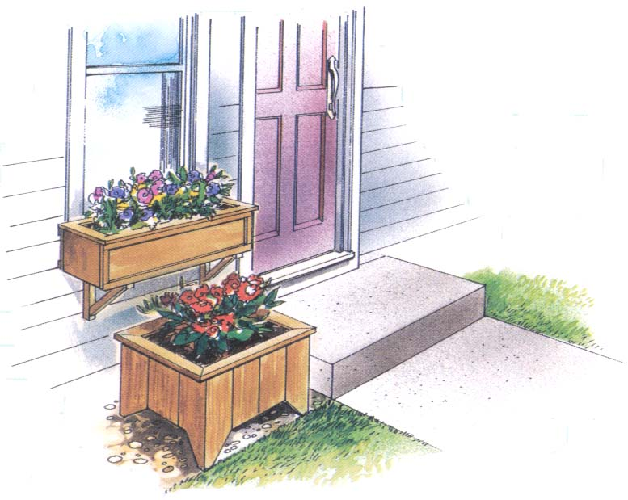

For some people, any size lawn is too much to maintain. Fortunately, there are many alternatives to consider.

Ground covers provide an alternative that offers a number of color and texture options in both evergreen and deciduous varieties, and work well in hard-to-reach areas in your landscape. Once established, they require very little maintenance and have great appeal to the weary gardener tired of mowing grass. These champions of the garden world keep the soil friable, or loose, ready to receive and percolate falling rain into the ground below. Seasonal bloom periods and interesting, vibrant fall colors result in an exciting and ever-changing landscape.

Many native ground covers thrive in shady areas in the landscape receiving less than ideal light. In North Carolina, they are well adapted to variable weather conditions and extremes. Under deciduous trees, in a woodland shade garden and even on the north or east side of a house, these
hardy ground covers boast distinctive leaf shapes and naturally resist pests.
Vegetable gardens do more than replace lawn areas. They provide home-grown produce for the dinner table. Consider intensive vegetable gardening – a method of growing vegetables and flowers together in relatively small spaces.

In areas close to the house, consider replacing some lawn area with a water garden, which can consist of just about anything that introduces water into your landscape: ponds, fountains, barrels of water, a bird bath or even a waterlily tub. Splashing water can provide a much-needed respite on a hot day for songbirds who find the sounds and cool surface irresistible. Once you see how water attracts wildlife, you may find yourself experimenting with several containers to create a veritable wildlife sanctuary right at home. Even a simple, shallow birdbath can entertain the apartment dweller with reflections and sounds previously unknown on a terrace or balcony.

Hedges are living fences that give you privacy without an artificial structure. Large shrubbery plantings also screen out objectionable views and sounds. Songbirds find living fences and shrub beds enticing homes, and the early morning chorus will reward your efforts many times over.

Patios and decks provide another alternative for land previously in turf grass. These outdoor living rooms are fun and, surprisingly, not too difficult to construct or install. Wooden construction and brick-on-sand building techniques slow down surface runoff and increase on-site percolation. Given the emerging popularity of do-it-yourself deck and patio construction, there are a number of instruction guides available. Look for them in your local public library, at home building retail centers, and at most full-service nurseries and garden centers.

Some gardeners convert their lawn area to trees, replacing an open lawn with the vertical strength of a forest in the making. This option requires careful selection of appropriate trees but can be very rewarding over time, especially in terms of reduced maintenance.

Beyond my home, what other gardening opportunities exist?
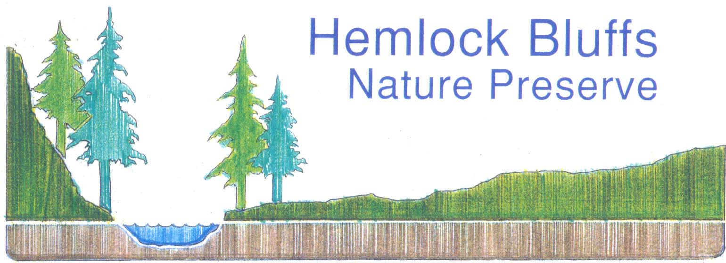

Many options exist that can expand gardening activities beyond your residence. Many city dwellers find the open ground at a street tree's base a suitable small garden plot for shade-loving plants, ground covers and even bulbs. Street trees provide not only wonderful shade and cool resting spots, but also generous amounts of oxygen to help keep the air clean and clear. These tall sentinels help to visually break up the urban skyline and introduce a textural softening to streets and buildings. Trees unite people in a neighborhood by providing a sense of identity, especially when a given species is planted together to define a specific area, such as a boulevard. Be sure to get permission in writing from your local municipality before planting around street trees. Along with permission, most municipalities will advise you about proper care and maintenance of the tree and your plantings.
In some urban communities, innovative forestry programs offer training for local residents, teaching them how to care for street trees. Open and abandoned lots have been completely reforested in some instances. Such patches of forest, however small, provide critical sources of oxygen and habitat enclaves within an otherwise artificial environment.

Grass strips between the sidewalk and street provide a unique gardening opportunity, assuming that local government regulations do not forbid such activity. Many flower gardens have found their way into these places, adding a splash of color to an otherwise dull street scene. Some municipalities have taken back portions of paved roads and reworked them for pedestrian use. A median strip in the middle of a broad avenue provides another source of color and texture when planted with trees, shrubs and flowers. These Conservation Landscapes add much to a city's personality.

Many urban areas in North Carolina have organized programs for local participation, such as community gardens. Generally, tracts of land currently not in use are made available for neighborhood projects such as vegetable gardens. Community gardens reward residents with free produce, healthy exercise, a sense of personal accomplishment and the beauty of a colorful garden where a
vacant or abandoned lot once stood. Whether you participate as an individual gardening in an assigned plot or as part of a group project, community gardens bring people together while working toward a common goal.

Neighborhood pocket parks managed by community associations provide sanctuaries from the noise and chaos of the busy city. These wonderful corners offer shade trees, shrubbery beds, flowers and bulbs, as well as a place to sit and enjoy the cool, green scenery right in the heart of the city. Pocket parks may be connected to larger parks by a common creek or stream, forming greenways enjoyed by cyclists, joggers, and birds and other wildlife. School and churchyards provide yet another opportunity for community gardening to add even more green space to the urban setting.

Since most of the population growth in North Carolina is projected for metropolitan areas, keeping these communities livable and pleasant has become increasingly difficult. Adding to landscape diversity through Conservation Landscaping responds to this challenge by:
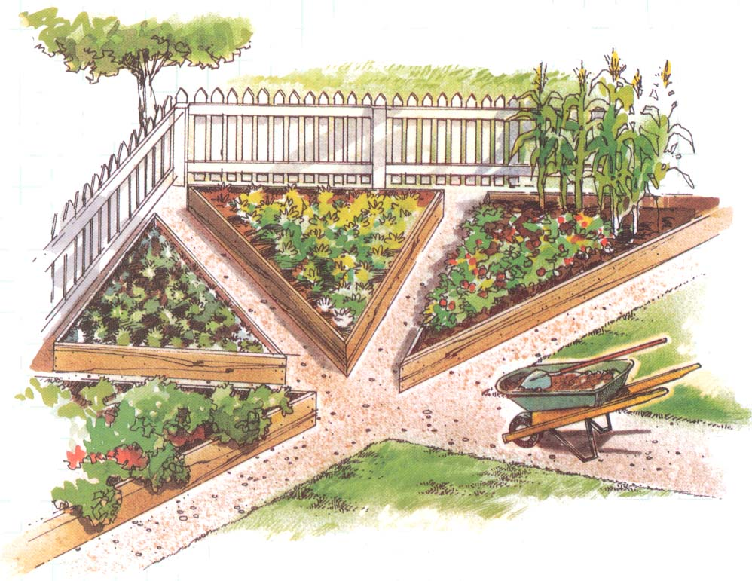

- moderating temperatures with additional shade trees
- trapping airborne pollutants with vegetation
- restoring places for birds and animals to live
- increasing porous surfaces that absorb precipitation and reduce runoff from the land into local waterways

Suggested Reading List

Clark, David E., ed. Basic Gardening Illustrated. Menlo Park, CA: Lane Publishing Company, 1975.

Cravens, Richard H. The Time-Life Encyclopedia of Gardening: Vines. Alexandria, Va.: Time-Life Books, 1979.

Crockett, James Underwood. The Time-Life Encyclopedia of Gardening: Container Gardening. Alexandria, Va.: Time-Life Books, 1974.

Damrosch, Barbara. The Garden Primer. New York: Workman Publishing Company, Inc., 1988.

Howard, Frances. Landscaping With Vines. New York: The Macmillan Company, 1959.

Pesch, Barara B., ed. Plants and Gardens. Brooklyn Botanic Garden Record: Water Gardening. Brooklyn: Brooklyn, Botanic Garden, Inc.,1985.

Ray, Richard M., ed. Container and Hanging Gardens. San Francisco: Ortho Books, 1975.

Taloumis, George, ed. Container Gardening. Handbook #85. Brooklyn: Brooklyn, Botanic Garden, Inc., 1979.

Wang, Linda, ed. The Town and City Gardener. Handbook #131. Brooklyn: Brooklyn Botanic Garden, Inc., 1979.
Related Websites

The Partners in Flight backyard habitat and native plant site. Has great information and a great list of relevant links.
http://www.faculty.ncwc.edu/mbrooks/pif/Home%20Page%20Links/resources_for_developing_backyar.htm

National Wildlife Federation backyard wildlife habitat site.
http://www.nwf.org/habitats/

The North Carolina Cooperative Extension water conservation site. Has good information on water conservation but some suggested plants are non-native.
http://www.bae.ncsu.edu/bae/programs/extension/publicat/wqwm/ag508_1.html

This guide produced through a partnership with the Stevens Nature Center of the Town of Cary and the NC Wildlife Resources Commission for NC Partners in Flight

Conservation Landscapes
Action Guide
Home Landscape Audit: Creating Diversity
Evaluate the many opportunities that exist for creating landscape diversity at your house or apartment.

GARDENING SITES  Opportunities for Conservation Landscaping | SITE CONDITIONS  Consider the Site | OBSERVATIONS/NOTES  New Landscape Ideas
Y / N Walls  - Do you have suitable wall space for a trellis?  - A hanging plant or two?  - A climbing vine or rambling vegetable vine?  - Dripping fountain?  - Night lights? (for a soft illumination of your garden on moonless nights) | - Sunny/shady  - Draft/wind  - Water source accessible and reliable?  - Other: ________________________
Windows  - Would a window box fit in?  - A lattice edge around the window?  - A box herb garden at the kitchen window?  - Bird feeders? | - Sunny/shady  - Window sill(s) space  - Problem masonry  - Operable/fixed window(s)  - Other: ________________________
Balconies  - Is there room for container plants?  - What about a vine on the rail?  - A small water garden against the wall?  - A windbreak? | - Sunny/shady  - Electric pump outlet  - Water source accessible and reliable?  - Other: ________________________
Patios, Decks  - Are there special kinds of containers and plants you want?  - How about wooden boxes for vegetables?  - A small terrarium or plastic hothouse for starting seeds?  - A bird bath site? | - Sunny/shady  - Frequency of use  - Good drainage  - Water source accessible and reliable?  - Other: ________________________
Stoops, Steps  - Would a small planted barrel fit?  - Can a potted plant or two thrive?  - How about a vegetable garden in small tubs?  - A fruit tree or accent tree?  - A flowering vine? | - Sunny/shady  - Confined space  - Water source accessible and reliable?  - Other: ________________________
Lawn Area(s)  - Is the lawn performing successfully everywhere?  - Are there places that could benefit from an alternative ground cover?  - Is the lawn area more than you wish to maintain? | - Sunny/shady  - Good drainage  - Ground cover sites  - Steep slope(s)  - Poor soil  - Saturated soil areas  - Other: ________________________

Containers

Many shrubs, vines and flowers can be grown in containers - let your imagination be your guide. Clay pots in baskets, urns, recycled metal cans, wooden tubs and rectangular wooden boxes are commonly used containers for patio and balcony gardens. Here are some tips to help you successfully garden in containers:

- In general, avoid plants that are known to have thick,
fleshy roots as they will not thrive in restricted spaces.

- Provide good drainage by ensuring that there are drain
holes in the bottom, below a layer of rubble, such as
clay pot shards, pebbles, or coarse gravel.

- Provide a good soil mix for growing. One good mix is
made from 3 parts peat moss and 1 part sand and 1 part commonly available potting soil.

- Provide sufficient water. Confined roots cannot seek out water, so you must water them generously and frequently.

- An annual or biennial root pruning will help keep perennials from outgrowing their container.

Water Gardens

A reliable source of fresh water in the form of a simple lined wooden barrel will attract wildlife to your garden, patio, or small balcony. With the addition of a water lily and perhaps another underwater plant, and a recirculating pump, your water garden can provide successful habitat for frogs. Here are some tips to keep in mind when water gardening:
- Periodically clean out and refill your garden, perhaps seasonally. If you use a recirculating pump and plants, this need only be done annually.

- Water should be available and accessible year-round. In the winter, an immersion heater will help keep water thawed out.

- Be sure to use a heavy-duty extension cord with a triple-pronged, grounded plug on any electrical equipment you install in your water garden.

- Choose a convenient and safe location. Most birds prefer a high perch and protective cover nearby to ward off danger and make a quick escape. Some birds prefer a water source with cover close by.

Window Boxes

Window boxes provide dramatic color in the form of flowers and vines that can be enjoyed from both inside and outside your house or apartment. The possibilities and combinations of colors and textures are numerous, but most window box gardeners use both viney, crawling-type plants interspersed with annual or perennial flowery favorites. A window box can be readily replanted to reflect the changes of the season. Here are a few tips for successful window box gardening:

- Be sure to follow the basic guidelines for container gardening discussed under Containers.

- A good mulch cover between soil and plantings will help reduce evaporation of water during hot weather.

- Select plants known to tolerate a range of light, temperature and exposure conditions.
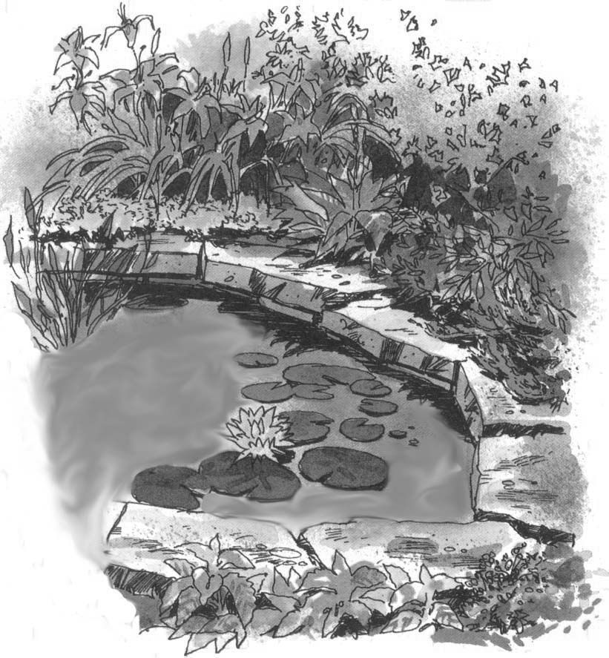

- Use nectar-producing plants to attract hummingbirds.

- For wintertime interest, consider a thick mulch cover for the soil and, with seasonal plantings removed, cover the box with a tray for feeding songbirds.

